**GROUP BY**

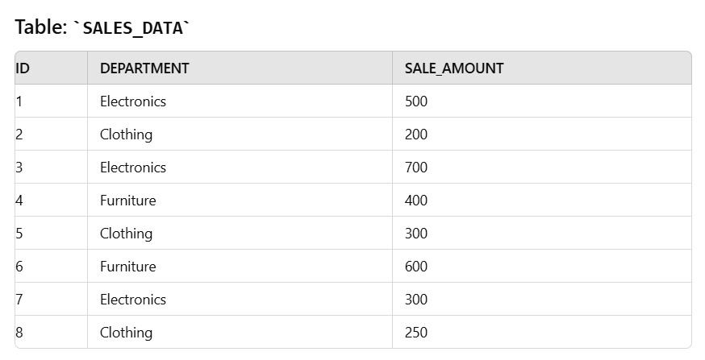

**SELECT** DEPARTMENT, SUM(SALE_AMOUNT) AS "TOTAL_SALES"

**FROM** SALES_DATA

**GROUP BY** DEPARTMENT;

**SELECT DEPARTMENT, SUM(SALE_AMOUNT) AS "TOTAL_SALES"**: Select the department and the sum of sales for each department.

**FROM SALES_DATA**: Specifies the table from which to retrieve the data.

**GROUP BY DEPARTMENT**: Group the rows by the DEPARTMENT column so that the SUM function can aggregate the SALE_AMOUNT for each department.

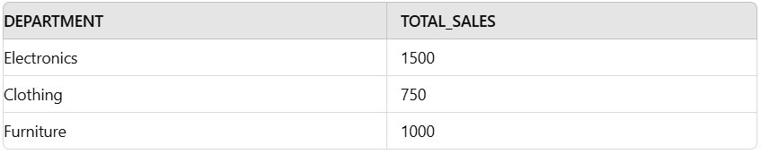

**Electronics**: The sum of SALE_AMOUNT is 500 + 700 + 300 = 1500.

**Clothing**: The sum of SALE_AMOUNT is 200 + 300 + 250 = 750.

**Furniture**: The sum of SALE_AMOUNT is 400 + 600 = 1000.

**GROUP BY**

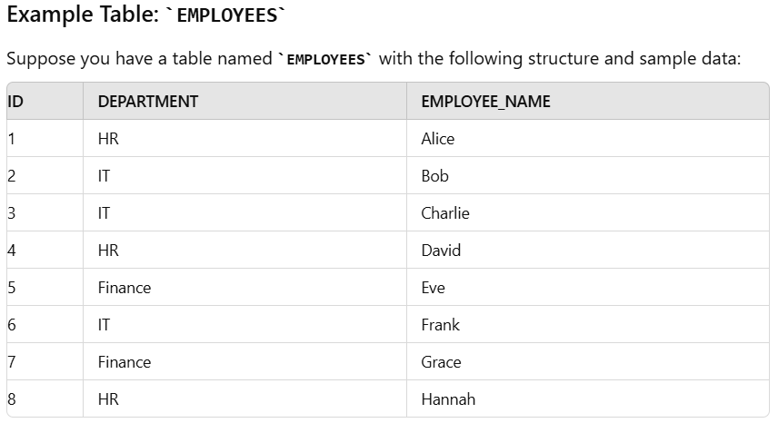

**SELECT** DEPARTMENT, COUNT (*) AS "EMPLOYEE_COUNT"

**FROM** EMPLOYEES

**GROUP** BY DEPARTMENT;

**SELECT DEPARTMENT, COUNT (*) AS "EMPLOYEE_COUNT"**: Select the department and the count of employees in that department. COUNT (*) counts the number of rows for each department.

**FROM EMPLOYEES**: Specifies the table from which to retrieve the data.

**GROUP BY DEPARTMENT**: Groups the rows by the DEPARTMENT column, so COUNT (*) calculates the number of employees for each department.

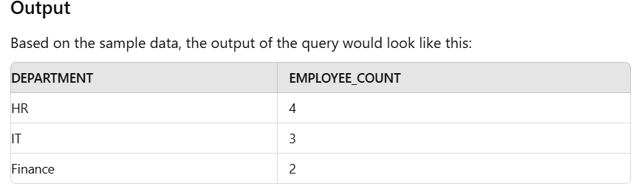

**HR**: The employee count is 3 (Alice, David, Hannah).

**IT**: The employee count is 3 (Bob, Charlie, Frank).

**Finance**: The count of employees is 2 (Eve, Grace).

**HAVING**

The HAVING clause is used in SQL to filter groups created by the GROUP BY clause based on aggregate functions. While the WHERE clause filters rows before grouping, the HAVING clause filters groups after the aggregation.

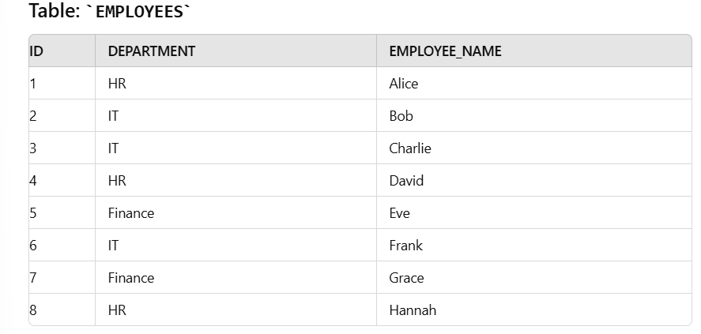

**SELECT** DEPARTMENT, COUNT (*) AS "EMPLOYEE_COUNT"

**FROM** EMPLOYEES

**GROUP BY** DEPARTMENT

**HAVING COUNT** (*) > 2;

**SELECT DEPARTMENT, COUNT(*) AS "EMPLOYEE_COUNT"**: This selects the department and counts the number of employees in that department.

**FROM EMPLOYEES**: Specifies the table from which to retrieve the data.

**GROUP BY DEPARTMENT**: Groups the rows by department, so that the COUNT (*) function can compute the number of employees per department.

**HAVING COUNT (*) > 2**: Filters the grouped results to include only those departments where the number of employees is greater than 2.

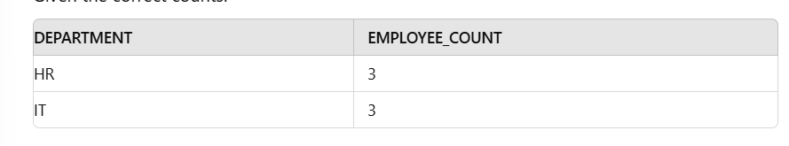

**HR** has 3 employees.

**IT** has 3 employees.

**Finance** has 2 employees, which is not greater than 2, so it’s excluded from the results.